Answer 1
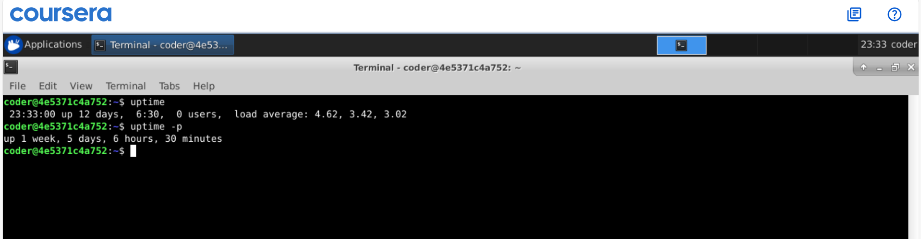
Explanation: Using uptime command we can see the uptime of the system. Also if use option -p it will give the output in weeks, days and further.

